**CSE Questions**

1. Illustrate with neat diagram the working of ISO/OSI layer architecture. Provide features and examples for each layer.

2. Write a program to create socket for client and server using TCP connections.

3. Illustrate with examples the characteristics of Connectionless (Datagram) Network. Use diagram wherever required.

4. For the network given in Figure below, Analyse and give the datagram forwarding table for each node. The links are labelled with relative costs; your tables should forward each packet via the lowest-cost path to its destination.

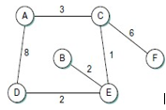

5. Calculate the delay × bandwidth product for the following links. Use one-way delay, measured from first bit sent to first bit received.

(a) 100-Mbps Ethernet with a delay of 10 µs.

(b) 100-Mbps Ethernet with a single store-and-forward switch

(c) 1.5-Mbps T1 link, with a transcontinental one-way delay of 50 ms.

(d) 1.5-Mbps T1 link between two ground stations communicating via a satellite in geosynchronous orbit, 35,900 km high. The only delay is speed-of-light propagation delay from Earth to the satellite and back.

6. Illustrate the working of Sliding window Protocol with suitable example.

7. Illustrate the characteristics of DHCP with examples.

8. Explain the following with its packet format and diagrams where ever necessary.

a) ARP b) ICMP c) CIDR 4)ATM 5)X.25

9. Analyse the network given below and create a routing table for node D using the link state algorithm.



10.Suppose A is connected to B via an Intermediate router R.The A-R link is instantantaneous,but the R-B link transmits only one packet each second one at a time .Assume A sends to B using the Sliding window protocol with SWS=4. For Time-0,1,2,3,4 state what packets arrive at and are sent from A and B. How large does the queue R grow(prob 37 in text book)

11.Given the extended LAN shown in Figure below, indicate which ports are not selected by the spanning tree algorithm. Also explain the algorithm with various steps.

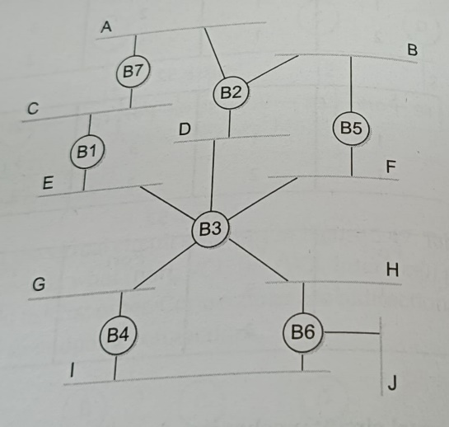

12.Explain Source routing and its types with a neat diagram.

13.Explain IPV4 Packet format.

14.Explain the OSPF protocol with its header format.

15.Problems on Subnetting.